Activity Worksheet
Where to locate a solar plant in Chile?

Suppose you want to build a solar power plant to supply electricity to Concepción. Given the good solar radiation conditions in the north, it is proposed to build the plant in Atacama. However, the distance between the two cities implies energy losses on the way, so the possibility of building the plant in the town of Concepción itself is also considered.

What would be the best place to locate a solar plant that delivers electricity to Concepción: the Atacama Desert or the surroundings of Concepción?

The following information is available:

 | Plant in Atacama | Plant in Concepción | 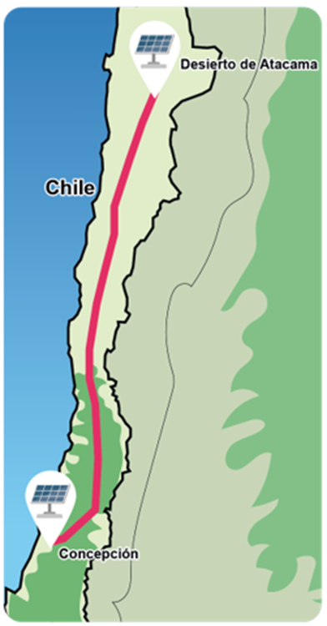
Power if the Sun per m² on the external surface of the atmosphere | 1,4 kW | 1,4 kW
Percentage of light that is absorbed by humidity before reaching the solar panel | 54% | 61%
Hours of sunshine per day* | 12 | 12
Sunny days per year* | 349 | 296
Percentage of light that is lost in the panel in heat and other effects | 80% | 80%
Percentage of energy lost in transmission cables | 9% | 0%

*Days and hours with sunlight conditions that allow the photovoltaic panels to operate. These are average values.

From a one square meter solar panel, how much electrical energy (kWh) reaches Concepción per day on average if the plant is built in Atacama? And if it is built in Concepción, which plant would be more efficient concerning the amount of energy reaching Concepción?
__________________________________________________________________________

Activity

Answer the following questions. Use a calculator and approximate to the third decimal place.

- Calculate the power that reaches the solar panel on each plant, considering what is lost due to the humidity of the atmosphere.

- One way to measure energy is in kWh (kilowatt hours). If there are 12 hours of sunshine per day on each plant, how much energy reaches the panel daily on a sunny day on each plant?

- How much energy (kWh) reaches a solar panel in a year, considering the number of days with sun on each plant?

- How much energy (kWh) reaches a solar panel on average per day in each plant?

- Of the average daily amount of energy that reaches the panel calculated in the previous question, how much does it arrive as electrical energy to Concepción from each plant?

- Considering the available information, what would be the best place to locate the solar plant?

