Practical Guide
The advance of the sea

Activity 1.

Below is a graph of a prediction of the advance of the sea in a coastal area of the Valparaíso region.

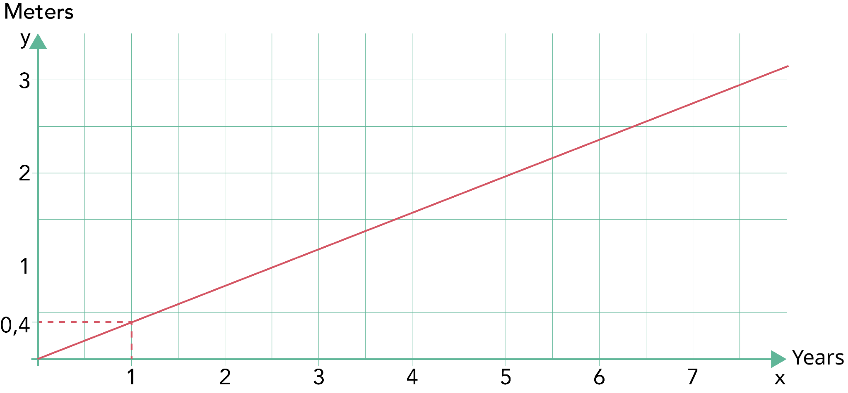
Answer :

- What type of proportionality does it correspond to? Justify.

- How much would the sea advance in this area after 9 years?

- What is the algebraic expression or formula that models this situation?

- Complete the following table using the formula found :

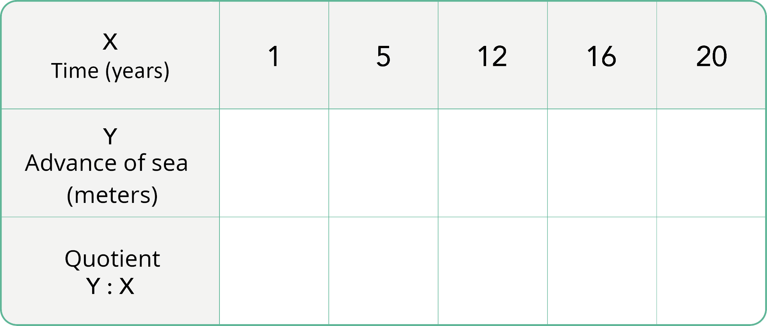

- In the year 2023, a house is located 30 meters from the sea on the coast of Valparaíso. In how many more years will the sea have reached the house? What year will it be?
Solver

Act . 1 | 1. | It is a direct proportionality, since it is a line that passes through the point (0,0).
 | 2. | Since each year the sea advances 0.4 meters, then, after 9 years the sea would advance 3.6 meters.
 | 3. | $$y=0,4⋅x$$
 | 4. | 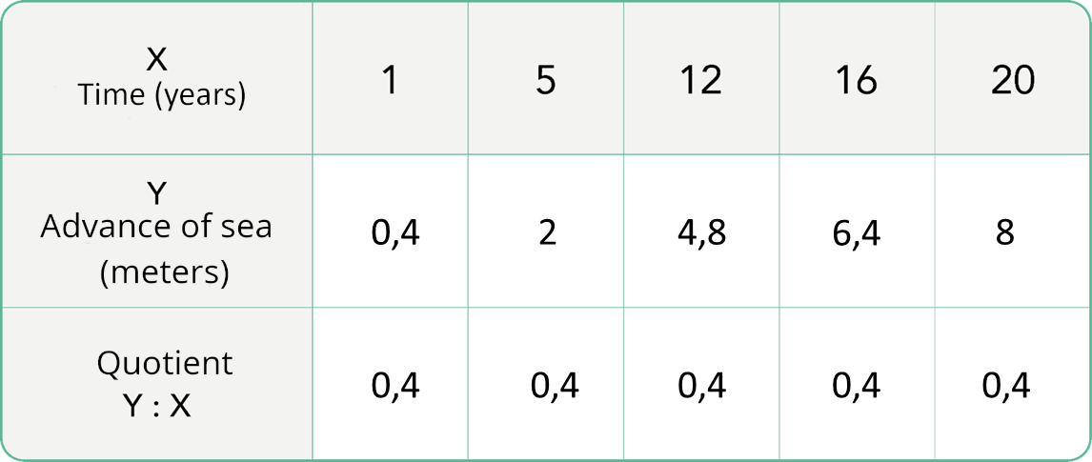
 | 5. | $30=0,4⋅x$  $x=\frac{30}{0,4}$  $x=75$  In 75 more years, that is, the year 2098, the sea will have reached the house.

