Worksheet
advance of the sea

Different predictions have been made about the speed at which the sea will advance in certain areas of the Chilean coast. Below are two of them:

- In Antofagasta the rate of advance of the sea will be 6 meters every 10 years .
- In Constitución the rate of advance of the sea will be 8 meters every 10 years.

Use the information provided to carry out the following activities.

- Draw the graphs of the sea advance predictions for each of the coastal areas mentioned.

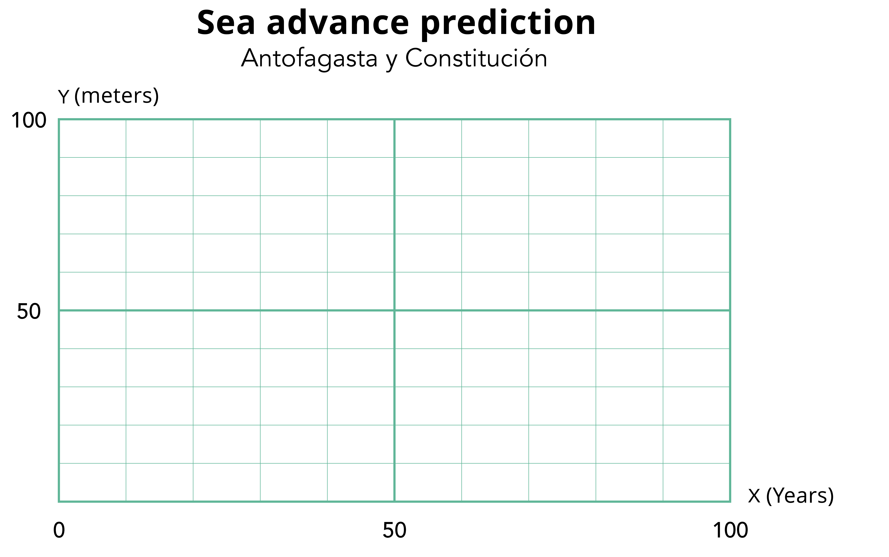

- In which coastal area is the sea advancing the fastest? How does it relate to the graph?

- How many meters will the sea have advanced in Antofagasta and Constitución in 50 more years?

- How many meters will the Antofagasta and Constitución sea have advanced in 30 more years?

- Write a formula that describes the relationship between time and the advance of the sea for the coastal areas of Antofagasta and Constitución.

- Use the formulas to calculate the advance of the sea after 2 years.

- In 2023, houses have been built a few meters from the beach in the coastal area of Antofagasta and Constitución.

- In Antofagasta, the house is 15 meters from the coast.
- In Constitución, the house is 20 meters from the coast.

- In each case, write on the signs the year in which the sea will advance the indicated meters.

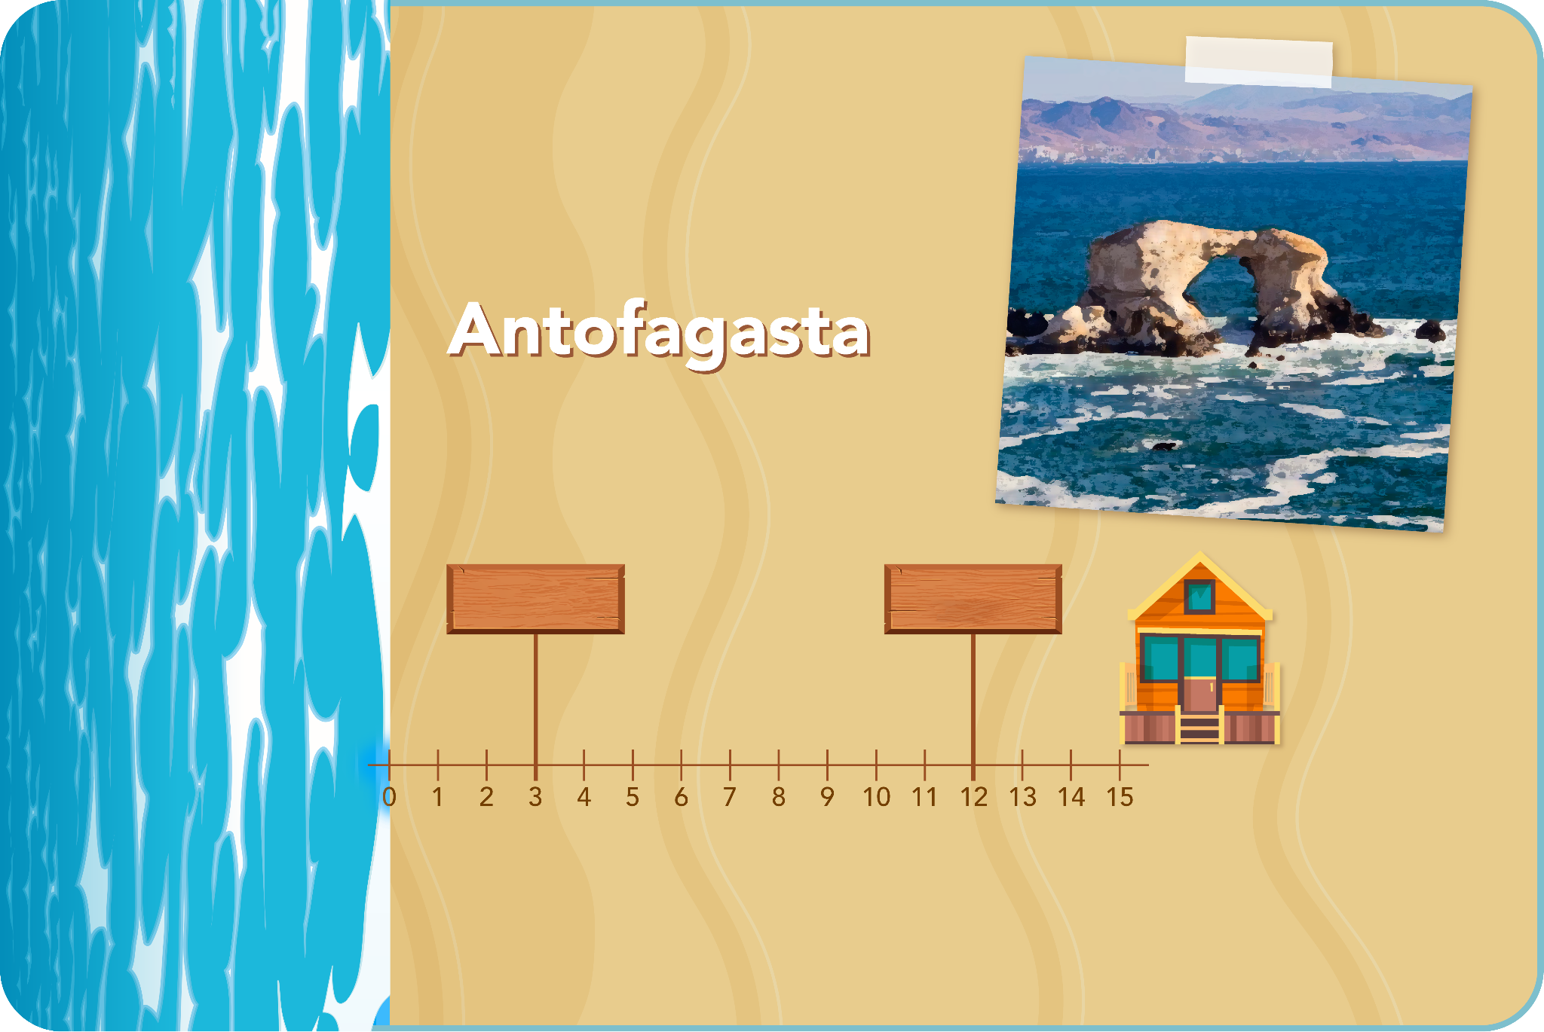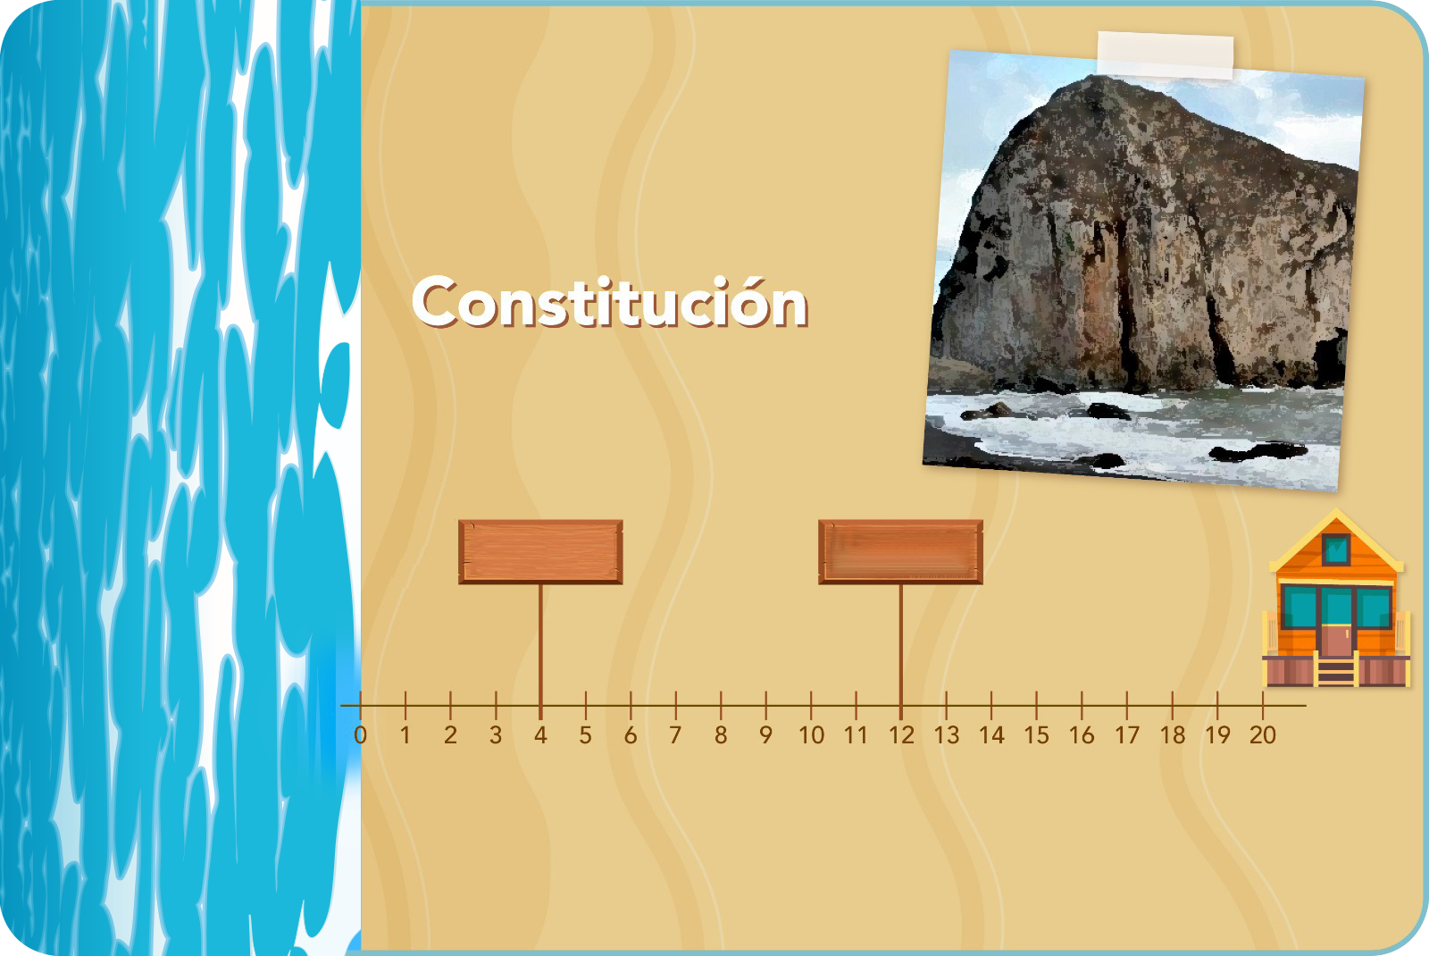

- Which house will the sea reach first? In what year?

